**Binary to BCD Conversion Algorithm**

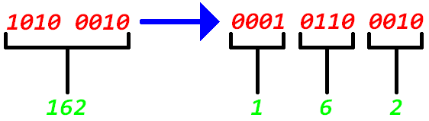

**Purpose:**

|  |  |
| --- | --- |
|  | Conversion of a binary number into separate binary numbers representing digits of the decimal number. *(this example is for 8-bits, other sizes follow the same pattern)* |

**Algorithm:**

1. If any column (100's, 10's, 1's, etc.) is 5 or greater, add 3 to that column.
2. Shift all #'s to the left 1 position.
3. If 8 shifts have been performed, it's done! Evaluate each column for the BCD values.
4. Go to step 1.

**Psuedo-Code:**

|  |  |
| --- | --- |
|  | PsuedoCode |

**Algorithm In Action:**

|  |  |
| --- | --- |
|  | Algorithm Table |

**BCD Conversion in Hardware:**

|  |  |
| --- | --- |
|  | ***Verilog:*** |

|  |  |
| --- | --- |
|  | Verilog Code |